

**Advanced Security 2 – Lab 2**

**DT211C**

**BSc in Computer Science**

**Tim Browning**

**C14519547**

School of Computing

Dublin Institute of Technology



# Source Code

I am using the add on Checkstyle to identify any security issues. I have in integrated it into Eclipse.

**SAMPLE CODE ERRORS**

The imports have the errors -

Using the '.*' form of import should be avoided - javax.crypto.*.

The class has the error –

“Abbreviation in name 'AES' must contain no more than '2' consecutive capital letters.”

1. “*Multiple markers at this line*

*- Line contains a tab character.*

*- 'while lcurly' has incorrect indentation level 16, expected level*

*should be 4.”*

*2. Multiple markers at this line*

*- 'try' child has incorrect indentation level 24, expected level*

*should be 6.*

*3. Multiple markers at this line*

*- 'if rcurly' has incorrect indentation level 32, expected level should be 8.*

*- '}' at column 5 should be on the same line as the next part of a multi-block statement (one that directly*

*contains multiple blocks: if/else-if/else, do/while or try/catch/finally).*

*- Line contains a tab character.*

*5. Multiple markers at this line*

*- 'ctor def' child has incorrect indentation level 16, expected level*

*should be 4.*

*6. Multiple markers at this line*

*- BlumBlum cannot be resolved to a type*

*- Line contains a tab character.*

*- 'if' child has incorrect indentation level 24, expected level*

*should be 6.*

These are six security issues, which have been shown by Checkstyle

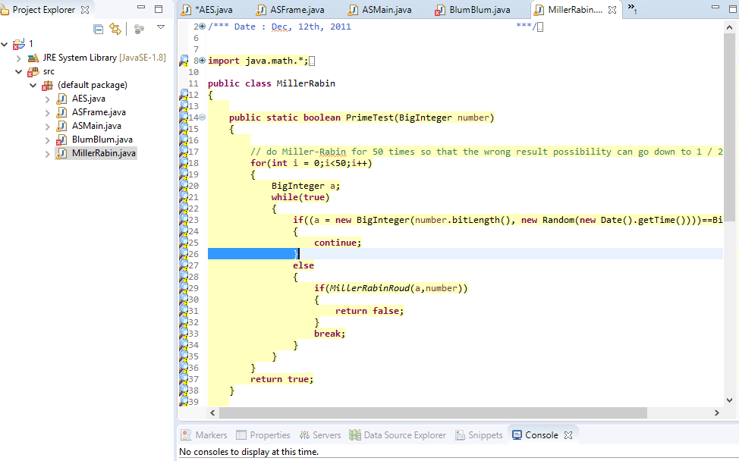

Figure 1 - Security Risks in sample code

# My Own *Source* Code

For my own program I will be using four classes Control.java, Employee.java, HourlyEmployee.java and MillerRabin.java.

Errors include:

*1. Multiple markers at this line*

*- Missing a Javadoc comment.*

*- Line contains a tab character.*

*- Line is longer than 100 characters (found 149).*

*- 'ctor def modifier' has incorrect indentation level 8, expected level*

*should be 2.*

2. *Multiple markers at this line*

*- 'method def modifier' has incorrect indentation level 8, expected level*

*should be 2.*

*- 'METHOD_DEF' should be separated from previous statement.*

3 *Multiple markers at this line*

*- Line contains a tab character.*

*- 'method def rcurly' has incorrect indentation level 8, expected level*

4. *Multiple markers at this line*

*- WhitespaceAround: '<' is not preceded with whitespace.*

*- WhitespaceAround: '<' is not followed by whitespace. Empty blocks may only be represented as {} when not*

*part of a multi-block statement (4.1.3)*

*- 'for' has incorrect indentation level 16, expected level should be 4.*

*- Line contains a tab character.*

*- WhitespaceAround: 'for' is not followed by whitespace. Empty blocks may only be represented as {} when not*

*part of a multi-block statement (4.1.3)*

*5. Multiple markers at this line*

*- WhitespaceAround: '+' is not preceded with whitespace.*

*- WhitespaceAround: '+' is not followed by whitespace. Empty blocks may only be represented as {} when not*

*part of a multi-block statement (4.1.3)*

*- WhitespaceAround: '+' is not preceded with whitespace.*

*- WhitespaceAround: '+' is not followed by whitespace. Empty blocks may only be represented as {} when not*

*part of a multi-block statement (4.1.3)*

*- WhitespaceAround: '+' is not preceded with whitespace.*

*- WhitespaceAround: '+' is not followed by whitespace. Empty blocks may only be represented as {} when not*

*part of a multi-block statement (4.1.3)*

*- WhitespaceAround: '+' is not preceded with whitespace.*

*- WhitespaceAround: '+' is not followed by whitespace. Empty blocks may only be represented as {} when not*

*part of a multi-block statement (4.1.3)*

*- WhitespaceAround: '+' is not preceded with whitespace.*

*- Line contains a tab character.*

*- Line is longer than 100 characters (found 136).*

*- 'method def' child has incorrect indentation level 16, expected level should be 4.*

*- WhitespaceAround: '+' is not followed by whitespace. Empty blocks may only be represented as {} when not*

*part of a multi-block statement (4.1.3)*

*- WhitespaceAround: '+' is not preceded with whitespace.*

*- WhitespaceAround: '+' is not followed by whitespace. Empty blocks may only be represented as {} when not*

*part of a multi-block statement (4.1.3)*

These five security errors occur in eclipse

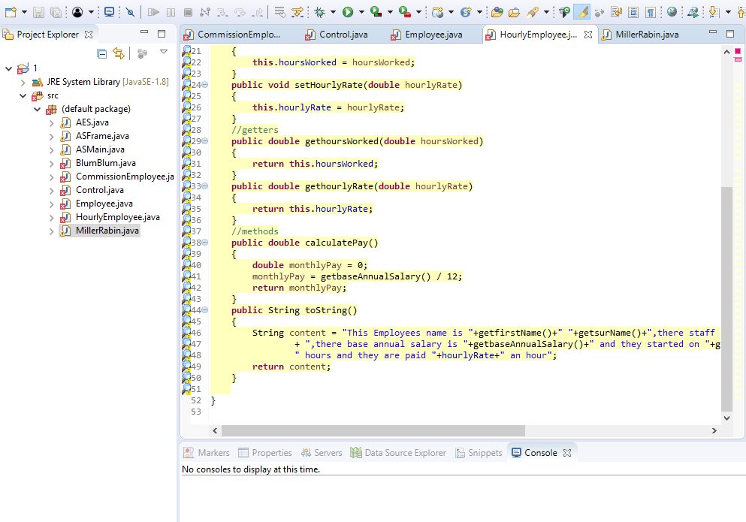

Figure 2 - Security errors in hourlyemployee class

.